**Moving .CSV Data into Hive**

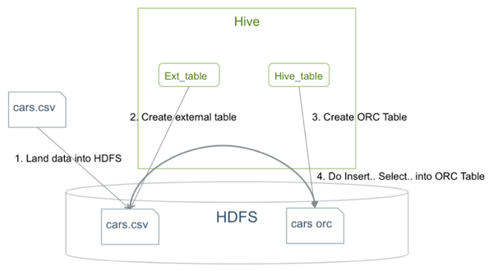

Fonte: HortonWorks

1. **Move .CSV data into HDFS**:
   1. The following is a .CSV file which contains a header line that describes the fields and subsequent lines that contain the data:
   2. [<username>@cn105-10 ~]$ head cars.csv
   3. Name,Miles_per_Gallon,Cylinders,Displacement,Horsepower,Weight_in_lbs,Acceleration,Year,Origin
   4. "chevrolet chevelle malibu",18,8,307,130,3504,12,1970-01-01,A
   5. "buick skylark 320",15,8,350,165,3693,11.5,1970-01-01,A
   6. "plymouth satellite",18,8,318,150,3436,11,1970-01-01,A
   7. "amc rebel sst",16,8,304,150,3433,12,1970-01-01,A
   8. "ford torino",17,8,302,140,3449,10.5,1970-01-01,A
   9. ...

[<username>@cn105-10 ~]$

<username> is the user who is performing the operation. To test this example, run with a user from your environment.

* 1. First, use the following command to remove the header line from the file because it is not part of the data for the table:

[<username>@cn105-10 ~]$ sed -i 1d cars.csv

* 1. Move the data to HDFS:
  2. [<username>@cn105-10 ~]$ hdfs dfs -copyFromLocal cars.csv /user/<username>/visdata
  3. [<username>@cn105-10 ~]$ hdfs dfs -ls /user/<username>/visdata
  4. Found 1 items

-rwxrwxrwx 3 <username> hdfs 22100 2015-08-12 16:16 /user/<username>/visdata/cars.csv

1. **Create an external table**.

An *external table* is a table for which Hive does not manage storage. If you delete an external table, only the definition in Hive is deleted. The data remains. An *internal table* is a table that Hive manages. If you delete an internal table, both the definition in Hive *and* the data are deleted.

The following command creates an external table:

CREATE EXTERNAL TABLE IF NOT EXISTS Cars(

Name STRING,

Miles_per_Gallon INT,

Cylinders INT,

Displacement INT,

Horsepower INT,

Weight_in_lbs INT,

Acceleration DECIMAL,

Year DATE,

Origin CHAR(1))

COMMENT 'Data about cars from a public database'

ROW FORMAT DELIMITED

FIELDS TERMINATED BY ','

STORED AS TEXTFILE

location '/user/<username>/visdata';

1. **Create the ORC table**.

Now, create a table that is managed by Hive with the following command:

CREATE TABLE IF NOT EXISTS mycars(

Name STRING,

Miles_per_Gallon INT,

Cylinders INT,

Displacement INT,

Horsepower INT,

Weight_in_lbs INT,

Acceleration DECIMAL,

Year DATE,

Origin CHAR(1))

COMMENT 'Data about cars from a public database'

ROW FORMAT DELIMITED

FIELDS TERMINATED BY ','

STORED AS ORC;

1. **Insert the data from the external table to the Hive ORC table**.

Now, use an SQL statement to move the data from the external table that you created in Step 2 to the Hive-managed ORC table that you created in Step 3:

INSERT OVERWRITE TABLE mycars SELECT * FROM cars;

|  |  |
| --- | --- |
| [Note] | **Note** |
| Using Hive to convert an external table into an ORC file format is very efficient because the conversion is a parallel and distributed action, and no standalone ORC conversion tool is necessary. |

1. **Verify that you imported the data into the ORC-formatted table correctly**:
2. hive> select * from mycars limit 3;
3. OK
4. "chevrolet chevelle malibu" 18 8 307 130 3504 12 1970-01-01 A
5. "buick skylark 320" 15 8 350 165 3693 12 1970-01-01 A
6. "plymouth satellite" 18 8 318 150 3436 11 1970-01-01 A

Time taken: 0.144 seconds, Fetched: 3 row(s)